Suggested Specification for Louisiana Clean Water State Revolving Fund
Project Sign

PART 1 GENERAL

1.1 SUMMARY

- This specification covers the fabrication and installation of a project identification sign for projects receiving funding through the Louisiana Clean Water State Revolving Fund Program.

PART 2 PRODUCTS

2.1 GENERAL

- The project sign shall be fabricated and erected within 21 days following the notice to proceed and shall be maintained by the Contractor until completion of construction and the Owner’s acceptance of the work.

- For projects which include greater than one funding source the information specified for CWSRF projects may be combined with other project signage requirements onto one sign, as allowed and approved by the funding agencies.

C. There should be one project sign per project. If the project has multiple locations, one project sign centrally located as directed by the Engineer is sufficient.

  - MATERIALS AND FABRICATION

- Refer to attached figure titled “CWSRF Project Sign Elevation” for typical layout of a sign. The size and spacing of the lettering on the sign may change to accommodate the addition of other funding agencies

- Sign Panel: The sign panel shall be constructed of 3/4-inch APA rated, A-B grade exterior plywood rabbeted into a 2” x 4” nominal frame or other suitable materials and construction capable of withstanding typical weather conditions common to the project site.

- Fasteners: All fasteners used in the fabrication of the sign shall be rust-proof.

D. Sign Supports: The sign shall be adequately supported and braced to remain in the proper positioning and alignment, including resistance to wind loads and toppling of the sign.

- Coating: All paint or exterior coverings used shall be exterior grade coating suitable for use on wood or the material of construction. The sign shall be prepared as follows:

Sign Face: The sign face background shall be white and can consist of a minimum two coats of paint.

Supports and Trim: The supports and trim shall be white and can consist of a minimum of two coats of paint. The front facing surface of the 2” x 4” frame shall be royal blue.

- Lettering and Emblem: The lettering shall be of the size and color as specified on the attached figure. The size and spacing of the lettering on the sign may change to accommodate the addition of other funding agencies. The emblem shall be of the size specified on the attached figure in royal blue.

PART 3 EXECUTION

  - INSTALLATION

- The project sign shall be erected in the location and alignment, as directed by the Engineer, with the bottom of the sign panel a minimum of five feet above existing grade.

  - MAINTENANCE

- The Contractor shall provide any and all materials required to maintain the sign in good condition throughout the duration of the Contract.

- The Contractor shall remove the project sign from the construction site upon completion of construction and Owner’s acceptance of the work, or when directed by the Engineer.

End of Section

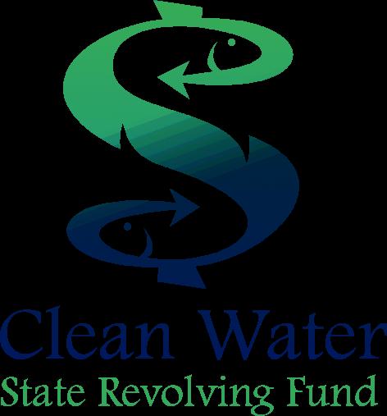
8’ – 0”

4’ – 0”
A
A
5’-0” min.
Section A-A
2” nominal
½ “
¾ “ APA Rated, A-B Grade Exterior Plywood
2’x4” Lumber Frame
Note: All lettering shall be
Green PMS 575 except as noted. Spacing between lines shall be 1” except as noted.
[Project Title]
[Municipality, Parish], Louisiana
Louisiana Department of Environmental Quality
This Project has been made possible with funding from the
Project No.: C__-_____-__-__
The Honorable [Municipal Official Name, Title]
Green PMS 575
Border around perimeter
White
Background
Engineered by: [Name of Engineering Firm]
Contractor: [Name of Contractor]
Black 2” Letters
Grade
CWSRF Project Sign Elevation (Not to scale)
Mitered Corner (typical)
4” Letters
4”
8”
2” Lettering
3” Letters
PROJECT SIGN SCHEMATIC
8”
Louisiana Clean Water State Revolving Fund Program

