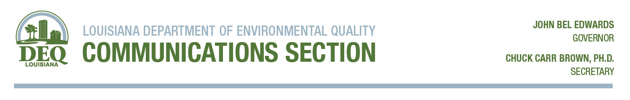
For Immediate Release: Contact: Jean Kelly
June 24, 2020 Telephone: 225-219-3966

LDEQ issues first Air Quality Advisory of the season
BATON ROUGE-Recently, the Louisiana Department of Environmental Quality issued the first Air Quality Advisory for the pollutant ozone of the year. May through October is traditionally considered Ozone season and it becomes even more important for the public to know about the current air quality and how it may impact activity and health. LDEQ, in conjunction with the Environmental Protection Agency (EPA), offers EnviroFlash, a convenient, free way to know about air quality.
With EnviroFlash, information is available to you on a daily basis or on-demand and it can be delivered to you on your phone or in your email. It is easy to subscribe to EnviroFlash. When the air quality is predicted to be in unhealthy for sensitive groups, orange level or above on the Air Quality Index, EnviroFlash sends an Air Quality Awareness advisory to subscribers. This advisory is a forecast of possible high ozone or fine particle (PM2.5). The system is also set up to send notifications of unusual events, such as fires, that might affect your air quality.
To stay better informed about ozone, particulate pollution and other air quality matters, the Louisiana Department of Environmental Quality encourages the public to sign up for the EnviroFlash system in their area: Baton Rouge, Shreveport, New Orleans, Alexandria, Lake Charles, Monroe, Thibodaux or Lafayette or on the DEQ web site, www.deq.louisiana.gov/enviroflash.
“Hot weather increases the risk of elevated ozone levels,” LDEQ Secretary Dr. Chuck Carr Brown said. “Because higher ozone and particle pollution can have an impact on public activity and health, we urge people to take advantage of the free EnviroFlash system. It’s a simple way to stay informed and take appropriate steps to protect your health.”
For more information on current air quality, go to the LDEQ website, https://airquality.deq.louisiana.gov/and the interactive EPA website: www.airnow.gov.

