Lead Hazard Notification Form (LHN)
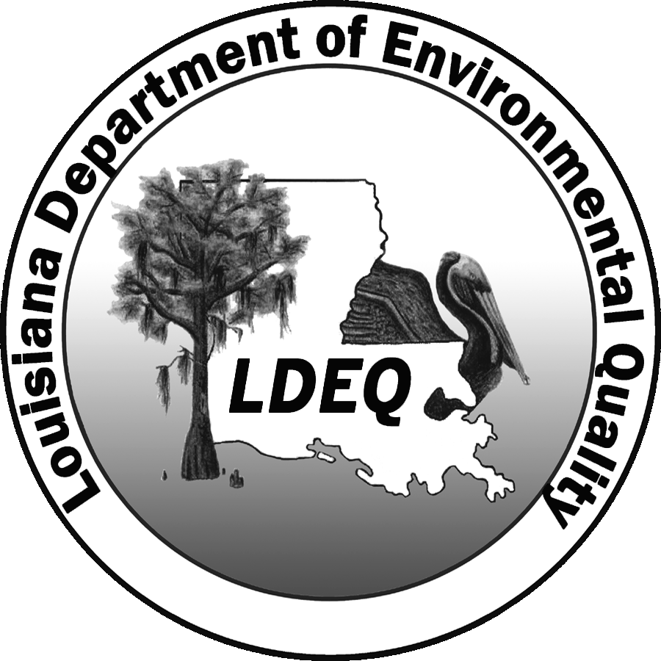

For LDEQ Use Only

Site AI No.

LHN No.

Date Received:

Processed Date:

for Child-Occupied Facilities

Louisiana Department of Environmental Quality

OES, PPPSD

Notifications and Accreditations Section
P.O. Box 4313, Baton Rouge, LA 70821-4313
Phone (225) 219-3300 Fax (225) 325-8282

This form must be completed by the owner or operator of the Child-Occupied Facility in accordance with LAC 33:III.Chapter 28.

I. Notification:
Property Name:
Property Address:
City: | Parish: | State: | Zip Code:
Property Owner/Manager Name: |  | Phone No. ( ) Fax No. ( )
Property Owner/Manager Address:
City: |  | State: | Zip Code:
Area of Property Where Hazard Found: |  | Email Address:
Square Footage/Acreage Inspected/Abated/Remediated:

II. Louisiana Accredited Inspector/Risk Assessor Used:
Inspector/Risk Assessor Name: |  |  | Phone No. ( )
Company/Contractor: |  |  | Fax No. ( )
Address: | City: | State: | Zip Code:
Inspector/Risk Assessor Accreditation Number: | Expiration Date: |  | Inspection/Risk Assessment Date:
Company/Contractor Accreditation Number: | Expiration Date: |  | State/Zip Code:
Date of Building Construction: |  |  | Email Address:

**Results of inspection reports and all sample data must be included with this submittal.

III. Louisiana Accredited Laboratory Used:
Laboratory Name: |  |  |  | Laboratory AI Number:
Address:
City: | State: |  | Zip Code: |  | Phone No. ( )
Laboratory Certificate No. |  | Certificate Issue Date: |  |  |  | Certificate Expiration Date:
Accredited Test Method used for determination:

IV. Abatement/Remediation Methods:
Briefly Describe Abatement/Remediation Methods:

Please be advised that any lead containing waste that has a TCLP level greater than or equal to 5.0 milligrams of lead per liter must be disposed of in a permitted Hazardous Waste Landfill.

V. Statements of Regulation Knowledge and Acknowledgment for Public Records:

(a) I hereby certify that this application, accompanying documents, and information provided is true and accurate in accordance with La. R.S. 30:2025.F(2)(a), any person who willfully or knowingly makes any false statement, representation, or certification in any form, application, record, label, manifest, report, plan, or other document filed or required to be maintained under this Subtitle are subject to penalties with conviction of civil and criminal actions as outlined in this regulation.

(b) I acknowledge that the information I have provided on or with this form is to be kept in the public records maintained by LDEQ. I also acknowledge that the information will be available for public inspection and copying, and I waive any claim to privacy in this information.

Signature of Property Owner: Date: ___________________________

Signature of Inspector/Risk Assessor: _______________________________ Date: __________________________

