
Lou Louisiana Department of Environmental Quality

September 2017

EQuIS Data Processor
User Guide
Revision 2

Contacts
For questions or comments contact:
LEADMS Administrator: Erin Folse
LDEQ, Underground Storage Tank Division
P.O. Box 4314
Baton Rouge, LA 70821-4314

DEQ-LEADMSQuestions@la.gov
Table of Contents

1.0 Introduction to EDP 1
2.0 Installing EQuIS Data Processor (EDP) Application 1
2.1.Downloading the EQuIS Data Processor (EDP) 2
2.2.Installing the EQuIS Data Processor 3
2.3.Downloading LDEQ’s format file 4
2.4.Registering the EDP 5
3.0 Using the Data Processor 8
4.0 Loading EDD Files 9
4.1.Loading EDDs Individually 9
4.2.Loading EDD data packages 10
5.0 Adding PDF Reports to your data package 11
6.0 EDD Errors 13
6.1.Error Logs 13
6.2.Correcting Errors 14
7.0 Features in EDP 14
7.1.Using Find and Replace 14
7.2.Clearing an EDD for the EDP 15
7.3.Saving changes to the EDD file 15
7.3.1.Saving EDD files as individual files 15
7.3.2.Saving changes to EDD as a data package 15
8.0 Sign and Submit a Data Package 17
9.0 Updating the Reference Value file 17
10.0 Updating the Format File 18
11.0 References 18
11.1. EarthSoft’s Website 18
11.2. LDEQ LEADMS web page 18
11.3. LDEQ’s Electronic Data Deliverables (EDD) Data Submittal Requirements Manual 18
11.4. Appendix A – Examples of EDD errors identified by the EDP 18

Introduction to EDP

The Environmental Quality Information System (EQuIS) Data Processor (EDP) is being made available to LDEQ data providers to check Electronic Data Deliverables (EDD) prior to submitting data to LDEQ. The EDP is used check EDD files to ensure they are formatted according to LDEQ’s Electronic Data Deliverable Submittal Requirement Manual for Louisiana Environmental Analytical Database Management System (LEADMS). If the EDP detects errors in the data, the errors will be identified by a color coding in the EDP program and/or via an error log. Once all errors are corrected the data provider should re-run the EDDs to assure no errors remain before submittal to LDEQ. This application also allows pdf documents to be attached to and submitted with the EDDs. The EDP application is a product of EarthSoft, Inc that checks all EDD files providing the user an interface to indentify and correct errors.
The purpose of this document is to assist LDEQ Data Providers with a means of checking the data before submittal against LDEQ business process and rules using the EDP application. Therefore, this document only provides information pertaining to LDEQ format specifications. If you would like a more detailed discussion of the EDP application, refer to EarthSoft’s web site at www.earthsoft.com.
Before being able to submit data to LEADMS each data submitter must first complete a subscriber’s agreement and mail to:
LEADMS Help Desk
ATTN: Erin Folse
P.O. Box 4314
Baton Rouge, LA 70821-4314

A copy of the agreement can be downloaded at: LEADMS Subscribers Agreement

Once LDEQ receives your completed form, a user account will be set up for you and you will be emailed a username, password, and all information you will need to submit data to LEADMS.

Installing EQuIS Data Processor (EDP) Application

The installation of the EDP involves four steps:
- Downloading the EDP application
- Installing the EDP
- Downloading the format file
- Registering the EDP

NOTE: You must be an administrator or have correct privileges on your computer to install EDP. The Microsoft .NET Framework version requirements should be checked before installing. Obtaining the correct version can be found on the Microsoft website at: http://www.microsoft.com/NET/. Microsoft .NET requirements for EDP can be found on the EarthSoft Louisiana DEQ EDP Format download page. Check with your IT support before installing.

  - Downloading the EQuIS Data Processor (EDP)

    - Clicking this link: http://www.earthsoft.com/wordpress/products/edp-format-for-ladeq/ will take you to EarthSoft’s EDP Format for LADEQ web page. You will see listed two links called EDP version 6.6 32 bit (x86) and 64 bit (x64). Click the link that applies to your operating system. (Note: The version number will change as the EDP is updated to correspond with changes.)

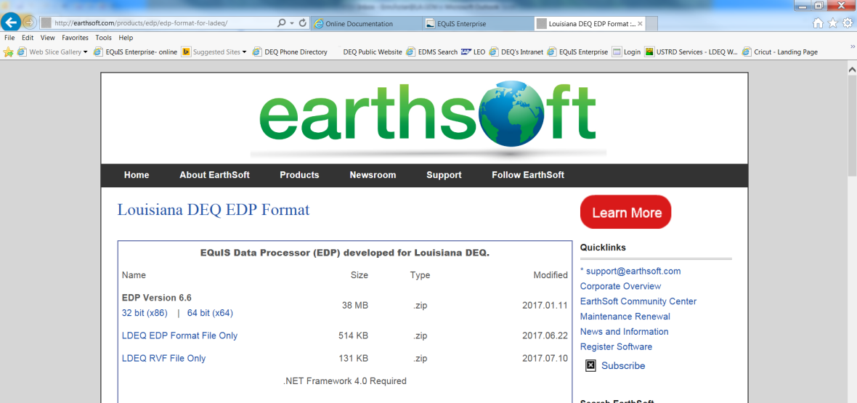
    - You should now have an Internet Explorer window asking if you want to Open, Save, or Save As the EDP_6.6.0_x??.zip file. You can select save as and select a place on your computer where you would like to save the file (desktop will work)

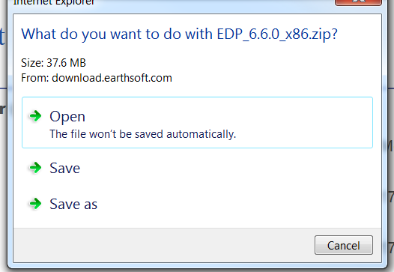

    - Open the directory where the EDP installation application was downloaded and unblock the file via steps below. (NOTE: When downloading files from the Internet, Windows may set an attribute on the file to “Blocked”. When this happens, the file will not load properly. Whenever you download a file, it is recommended that you check for the blocked attribute and “Unblock” the file so it will load properly.)
      - Right-click on the file, then select properties. A file properties window will display. If the file is blocked you will see the “Unblock” button in the general tab. Clicking the “Unblock” button will remove the restriction on the file.

  - Installing the EQuIS Data Processor
    - Create a new folder on your desktop and name it EDP. After the downloaded file is unblocked, unzip it to this new folder you created. Open the new folder and double-click on the application installer to open Installation Wizard that will guide you through the installation procedure. (NOTE: During installation you should not have other programs running)

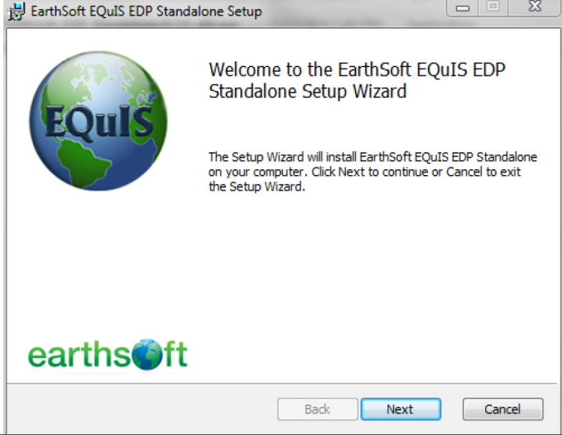

Click “Next”. The License Agreement screen will appear. Select “I accept the license agreement” button and click “Next”

Select “I accept the license agreement” button and Click Next.

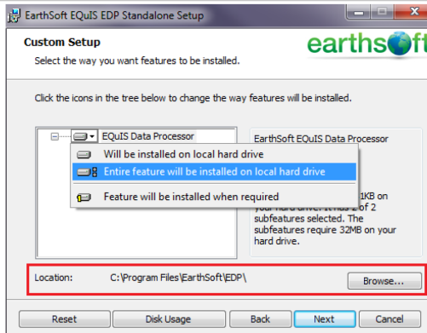

Click the icon next to ‘EQuIS Data Processor’ and select ‘Entire feature will be installed on local hard drive’. At the bottom of the window, you should see location and it should default to: C:\Program files\EarthSoft\EDP. Click the “Next” button and you will reach the “Ready to install” screen.

Click the “Install” button to begin the installation. When the installation is done, you will be presented with a window that verifies that the EDP has been successfully installed.

Click the “Finish” button to exit the installation.

  - Downloading LDEQ’s format file

Next you will need to download LDEQ’s format file and unblock it using the same instructions as above. The format can be found on the same web page at:

http://earthsoft.com/products/edp/edp-format-for-ladeq/

Click on the link called LDEQ EDP Format File Only. You do not need to unzip this folder. Just unblock it and move the zipped format folder into C:\Program Files\EarthSoft\EDP\Formats folder.

  - Registering the EDP

Once the application is installed it must be registered. Start the EDP application by selecting:

Start > All Programs > EarthSoft > EQuIS EDP Standalone.

The first time you open the EDP application you need to open the format file. The EDP application will open with a blank screen. Select “Format” from the menu. Select the file in C:\Program Files\EarthSoft\EQuIS\Formats\LDEQ.xse file and click Open.

An EDP registration screen will appear. Click the “Register” button.

A Software Registration screen will display and “click here” to request registration key for this computer.

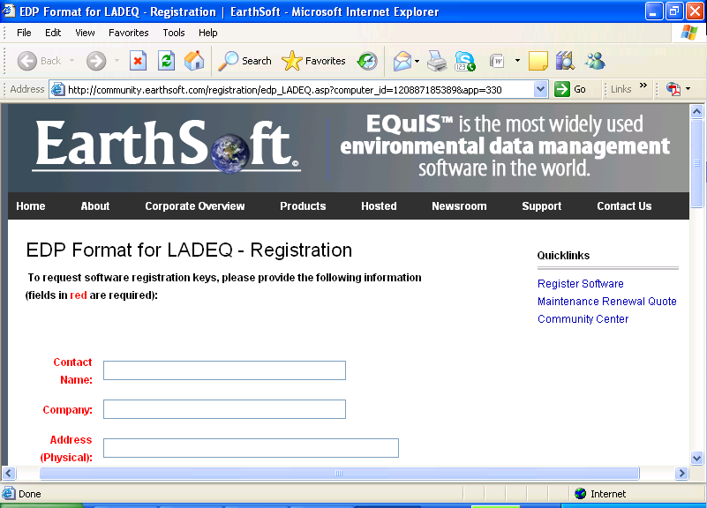

An “EDP Format for LADEQ – Registration” screen will appear. You will first be asked if you submitted your subscriber agreement. If so, click “Yes” and enter all the requested Client Information in the “Registration” form. In the comment field indicate that you are registering a new license. When complete, click Submit.

You will receive an email with a registration confirmation for the registration key request and soon after you will get an email with the registration keys.

Once you have received your registration keys copy them from the e-mail, then open EDP by clicking on Start>All Programs>EarthSoft>EQuIS EDP Standalone. Click on the round note pad icon at top left corner 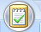 then select “Register” to open the Software Registration window. Paste the registration keys you copied from the e-mail to the New Key Codes field in the Registration window then click on Save Keys.

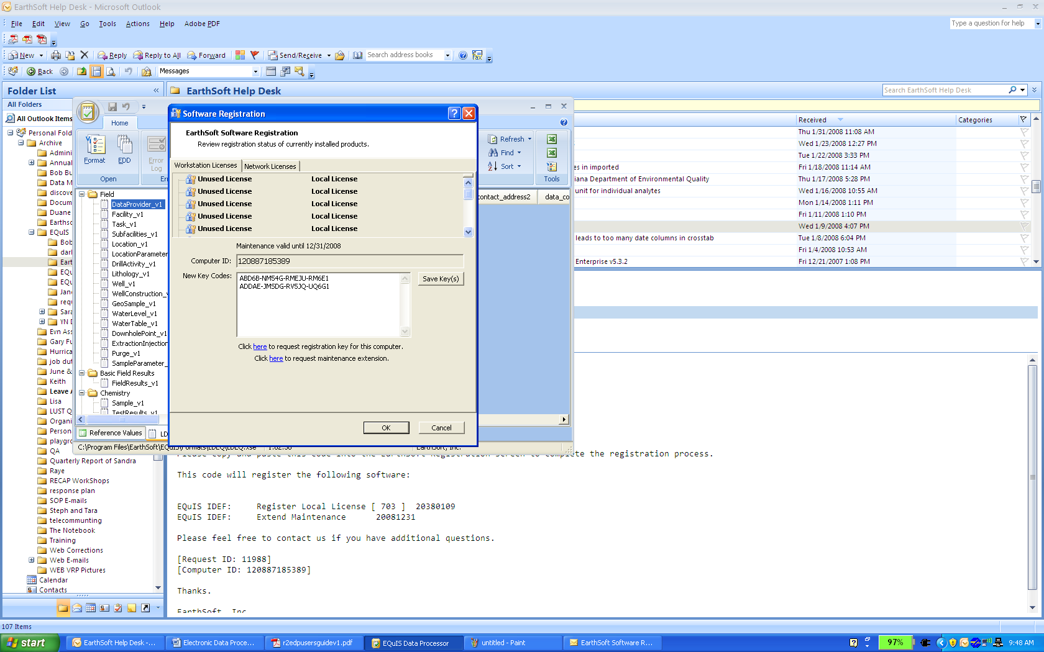

The EDP should now have a window saying registration was successful click OK then OK to close the registration window.

NOTE: Registration is unique to each computer.

Using the Data Processor

EDP is a powerful tool that can check for data completion and referential integrity, identify errors and create compressed files containing multiple related EDDs in a single useable format for upload and storage in a relational data base system. Sections below detail starting, loading, identifying, and correcting errors and saving your data for submission to Louisiana Department of Environmental Quality.
Starting EDP
Start the application by selecting Start>All Programs>EarthSoft>EQuIS EDP Standalone

The EDP will open. The first time you open EDP after initialization you will need to choose a format file to open. To do this select the format icon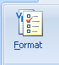 Browse to C:\Program Files\EarthSoft\EDP\Formats\ LDEQ.xse
If not already selected, select the “LDEQ” tab at the bottom of the screen. The following screen will appear with a list of EDDs in LDEQ format file along the left side of the screen and an empty table with field names associated with the highlighted EDD.
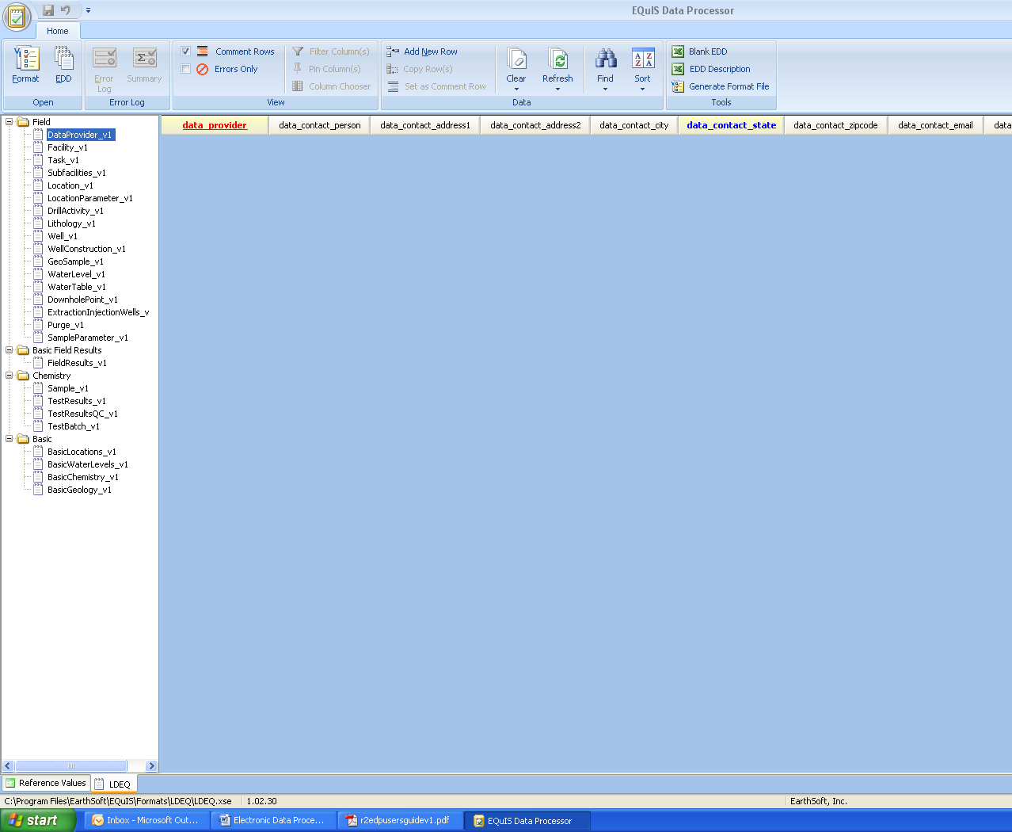
Each EDD file listed corresponds to the EDD files describing the LDEQ’s EDD Submittal Requirement Manual for LEADMS.
In the figure above the DataProvider_V1 is selected and the associated fields are listed in the table.
Red text fields are required fields and cannot be left blank; they must be populated with data. Blue text fields are fields that require a valid value. All valid values are listed in Appendix A of LDEQ’s EDD Submittal Requirement Manual. You can obtain hints about each data field by placing the cursor over the field name.

Loading EDD Files

EDD files can be loaded individually or as a package to be checked by the EDP.

  - Loading EDDs Individually

To load EDDs individually, select the section of the format to be checked from the list on the left. In example below, a sample_v1 file is going to be checked therefore sample_v1 is highlighted. Next load the EDD by clicking on the EDD icon in the menu or by right clicking on the selection and select “Load Data File”. Browse to the EDD file you want to load and select “Open”. The data file will load and be checked. Data will be displayed in the table and any errors detected will be color coded. NOTE: If your data file has header rows, EDP will identify it as an error unless each header row is preceded with by a # in first column of each header row.

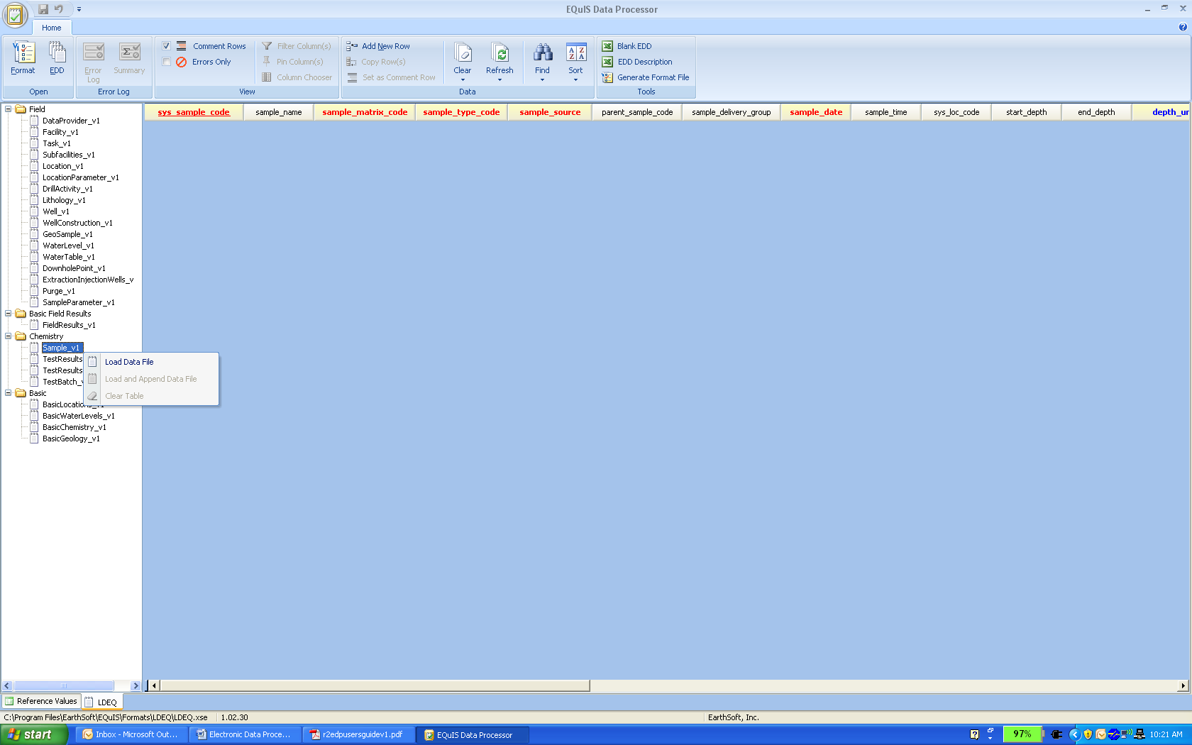

  - Loading EDD data packages
You can load the EDDs as a package as long as all EDD text files are zipped and named according to the name convention described in the EDD Submittal Requirement Manual. To create the package WinZip the EDDs you created for a project. Click the EDD icon located in the top menu. Browse for the zip file you have packaged the EDDs in and select “Open”. All the data files will be loaded into the EDP and checked.

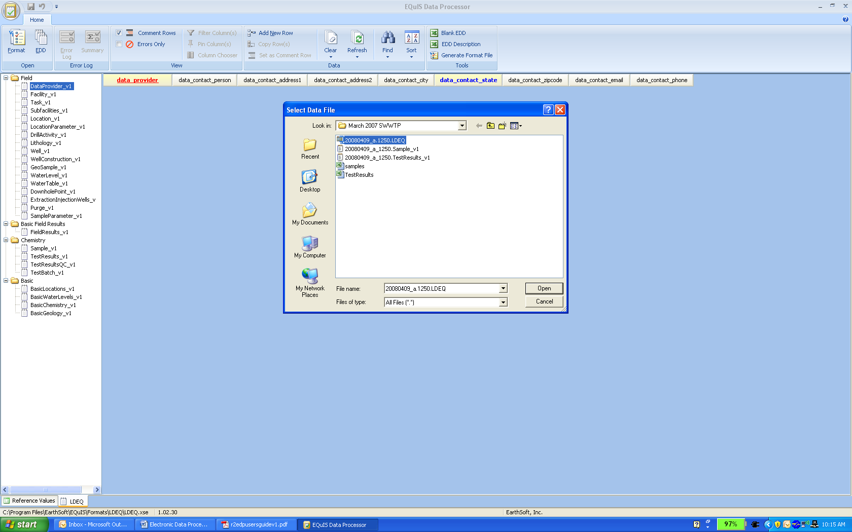
EDDs can be loaded all together if the EDDs were created in the excel template where each worksheet in the excel file is an EDD. Excel templates can be loaded by clicking the EDD icon and browsing for your saved excel file and click open.

NOTE: If there two different excel files with data that you want to submit together you can load them to together. To do this load the first file by clicking on EDD icon and browsing for your one saved excel file and click open. Then right click on one of the files in the left pane with date and click on load and append data file and browse for your second excel file then click open. Adding PDF Reports to your data package
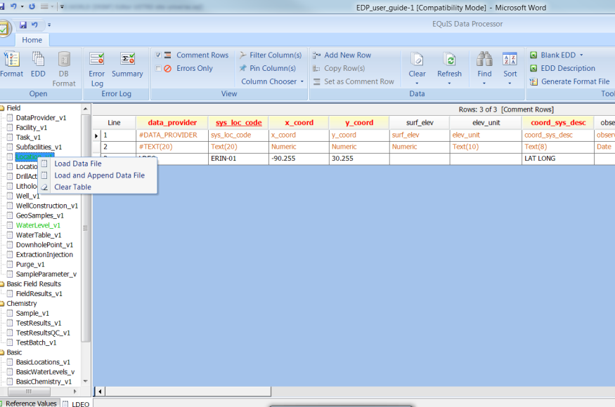

Adding PDF Reports to your data package

LDEQ’s format file contains a table for uploading pdf reports. The report can be added to your EDD data package and submitting electronically.
Once you have loaded your EDDs, checked and corrected, you can add the report that goes along with the analytical data you are submitting. To do this, on the left side of the EPD click on the table called file_v1.
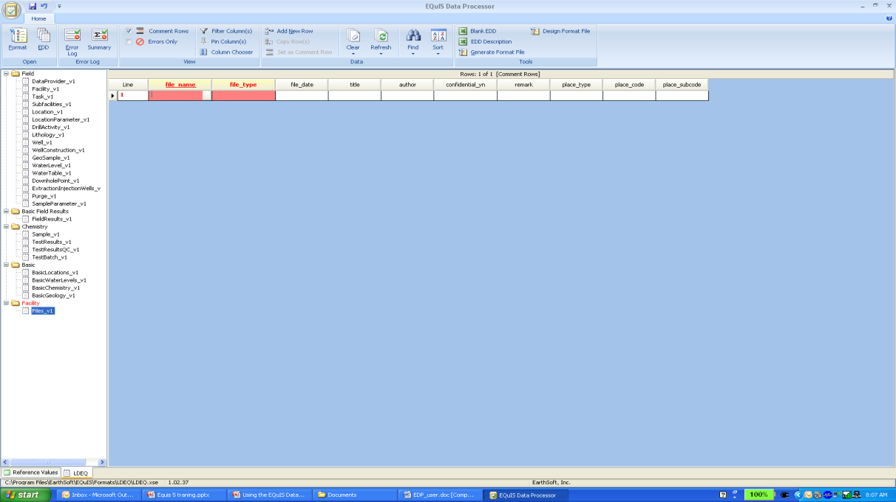
In the top menu, click on “add a new row”. A new row will be added under the file name column, and if you place your mouse over this field you will see a gray button. Click on that button and browse your computer to find the pdf report you need to add to your data package, select the file, and click “open”. The pdf file you selected will appear in the file name row, the file type will auto populate with.pdf, and the file date and time will automatically appear in the file date field. If more than one volume of a report needs to be added to this data package, in the title field select from a drop down list the volume number of the first report, again click on “add new row” and add another file using the process described above and selecting the next volume number. There is a drop down list in the column place_type. This is where you can select the routing group your report is to be sent too. The reports you added will be adding to the data package zip file and submitted along with the EDDs that will be imported into LEADMS. Once you are ready to submit your data package to the system, go to section 8 for instructions.
Note: We do have some limitations on file sizes and number of pages in a report. See below of a list of pdf report parameters:
    - PDF must not have over 999 pages.
    - Each individual file added must not exceed 50MB.
    - Maps should likely not be over 11 X 17 if at all possible.
    - Photos normally should not have high pixel count unless there is a real need.
    - Data table fonts should be at least 10 pt.
    - Submittals may be more than one volume with the total size of all volumes not to exceed 120 MB. If more that one volume is submitted, the title field must be filled out with a volume number.
    - PDFs must contain a signed transmittal letter as page two of volume. This letter should include the AI #, name, and physical address in the RE section.

EDD Errors

In the example below rows 3, 4, 7, and 17 have errors. If you place the cursor over the error, the type of error will display. Each type of error is indicated with a different color code. Each error must be resolved before submitting the data to LDEQ.

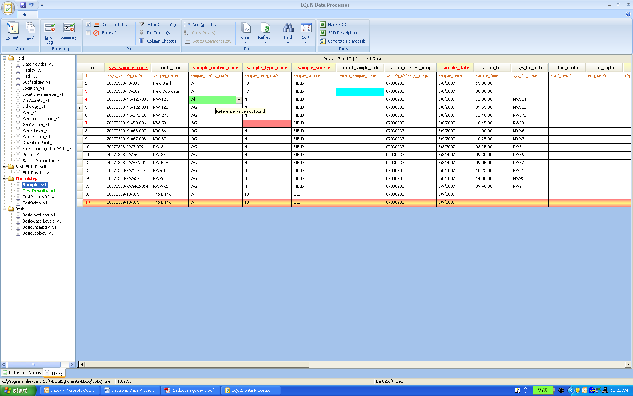

To view only the row with errors, check the box next to “Errors Only” in the menu bar. To restore uncheck the “Errors Only” box.

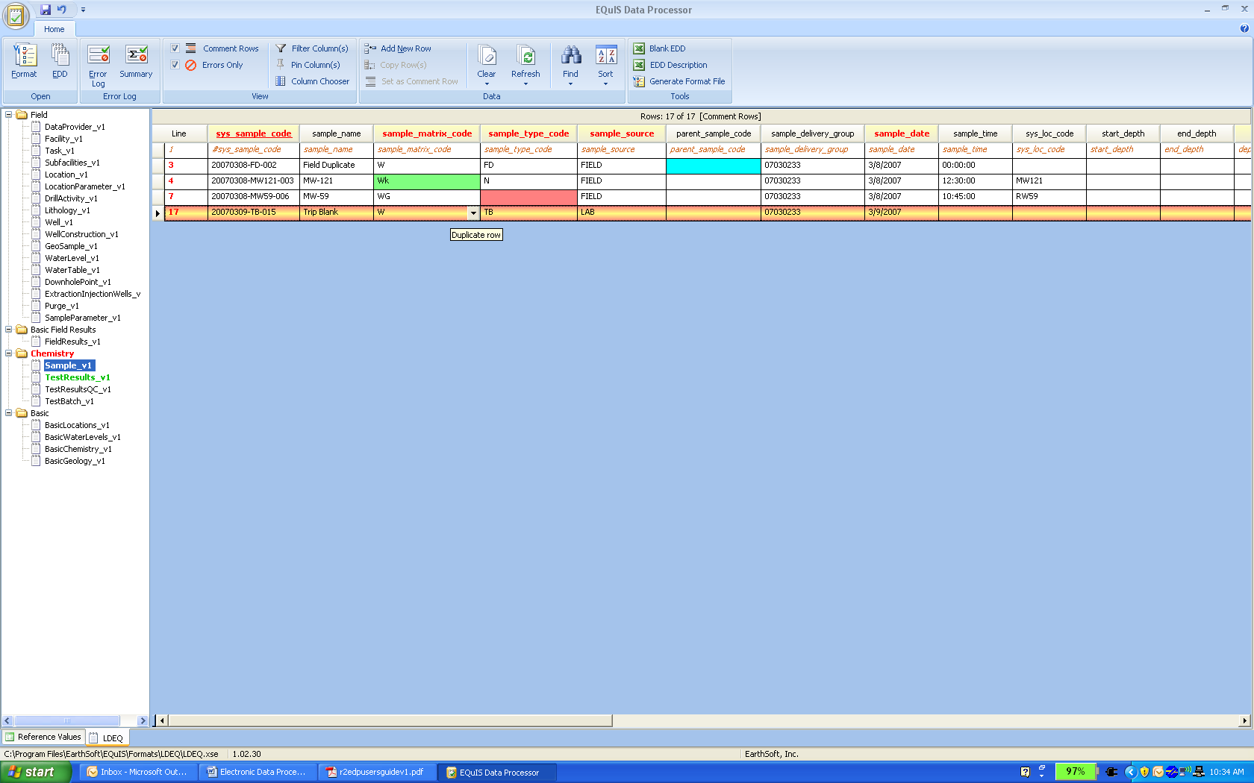

  - Error Logs

The EDP can produce error logs that can be saved as an html formatted file. The Error Log is a detailed list of errors and is a summary of the errors found. In the menu, select “Error Log” or “Summary”. Decide where you want to save these files on your computer then select “Save”. The error log will be saved in the folder you selected.

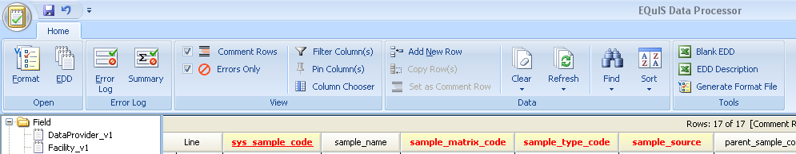

  - Correcting Errors

As data is loaded into the application, it is being checked for errors. Lists of typical errors are described in Appendix A.

The user can correct the errors directly in the EDP application by clicking the field with the error and changing the data to the correct value. If the field is restricted to a list of valid values, the possible values will be provided from a drop down list in the field. If the error is corrected, the color shading will disappear. Once a change is made, save the changes by saving corrected file following process in section 7.3.

Features in EDP
  - Using Find and Replace

The find and replace function is good to use when a number of the same errors are found. With Find and Replace, you can search the file for a specified value and then replace it with the correct value.

The “Find and Replace” function is activated by selecting the binocular icon located in the Data menu. When the “Find and Replace” window appears, type the value to be replace in the “find what” field and the new value in the “replace with” field. Select “find” to view fields with the value and “replace” to replace the original value with the new value.

  - Clearing an EDD for the EDP

To clear the data from the EDP, select “Clear” from the top menu, then select “Clear EDD”. The EDD will be cleared from the interface. Note: The EDD file will not be deleted from your computer.

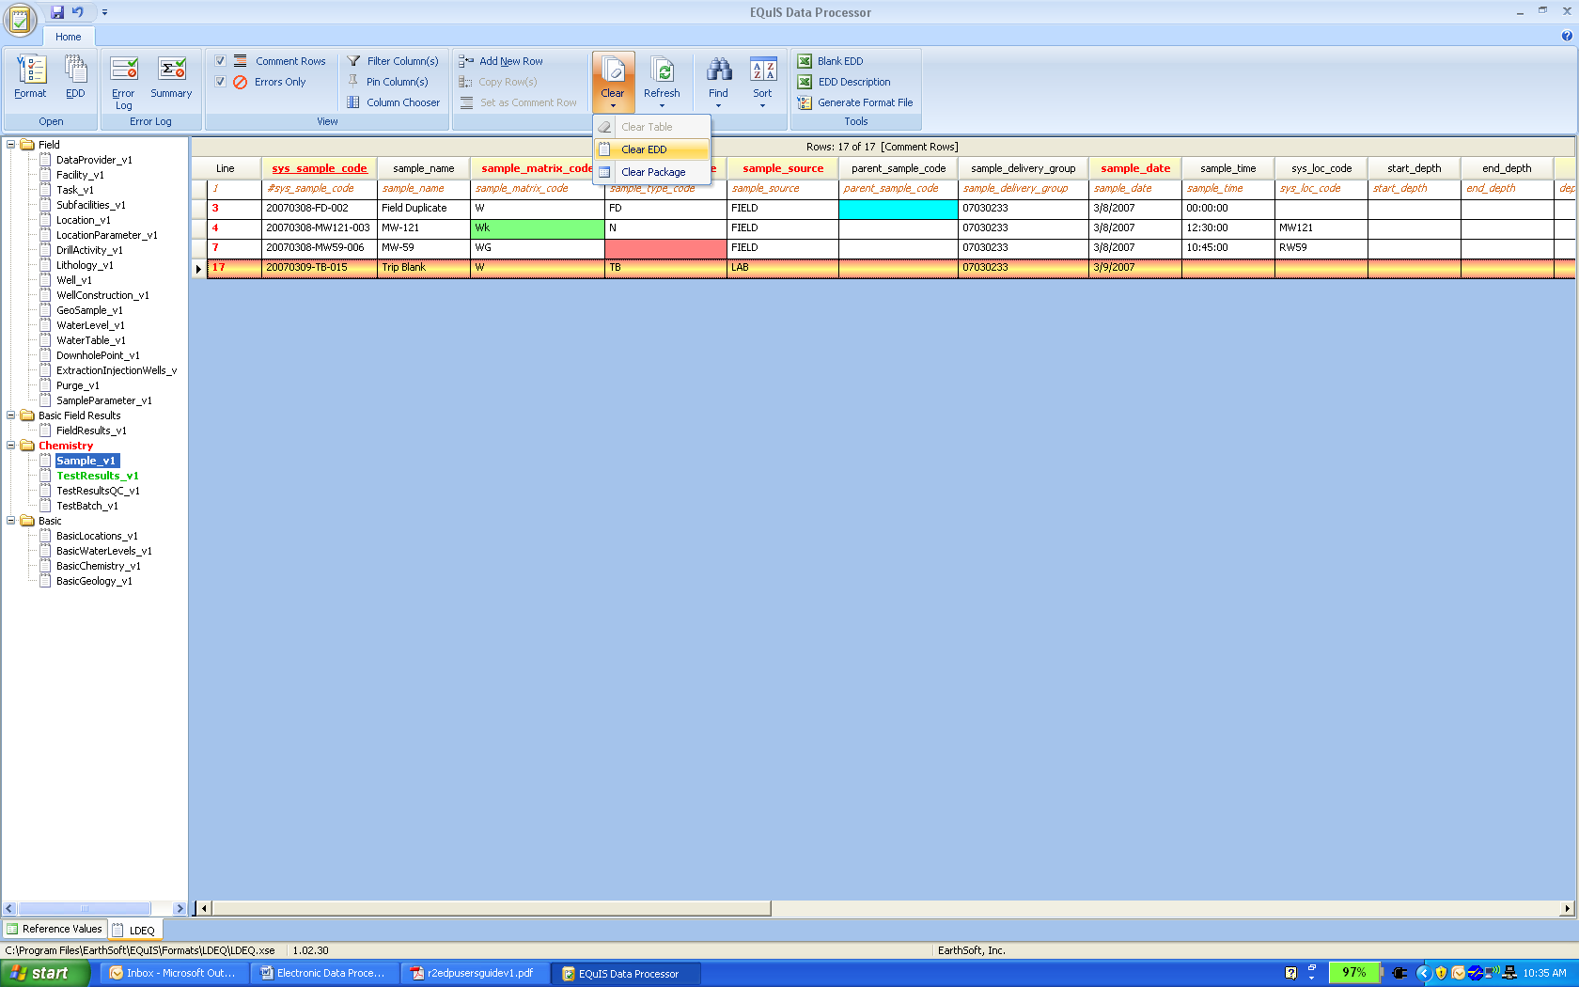

  - Saving changes to the EDD file
    - Saving EDD files as individual files

To save any changes made to the EDD data file first highlight the file in the left pane you want to save, then click the icon located in the upper right hand corner and then select Save>EDD. Browse to the folder where you want the EDD file to be saved, enter the file name, and select “save: Changes to the EDD are now saved.

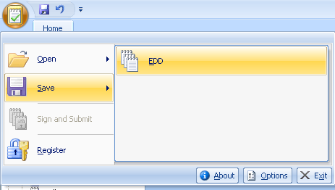

    - Saving changes to EDD as a data package

Once all data has been corrected you can save your data package on your computer using the sign and submit tool in EDP. To do this, with the corrected data opened in the EDP application, click on icon in the upper right hand corner and select Sign and Submit.

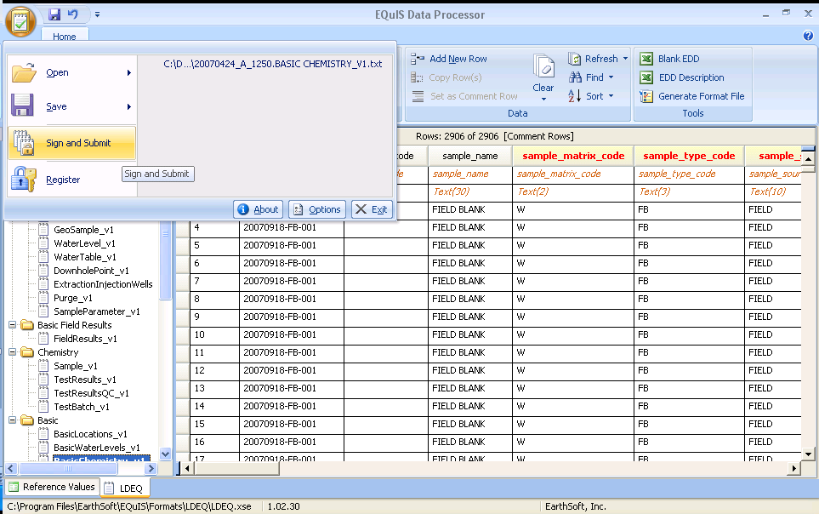

Enter your user name, password, the AI number, and the Facility Name in the appropriate fields.

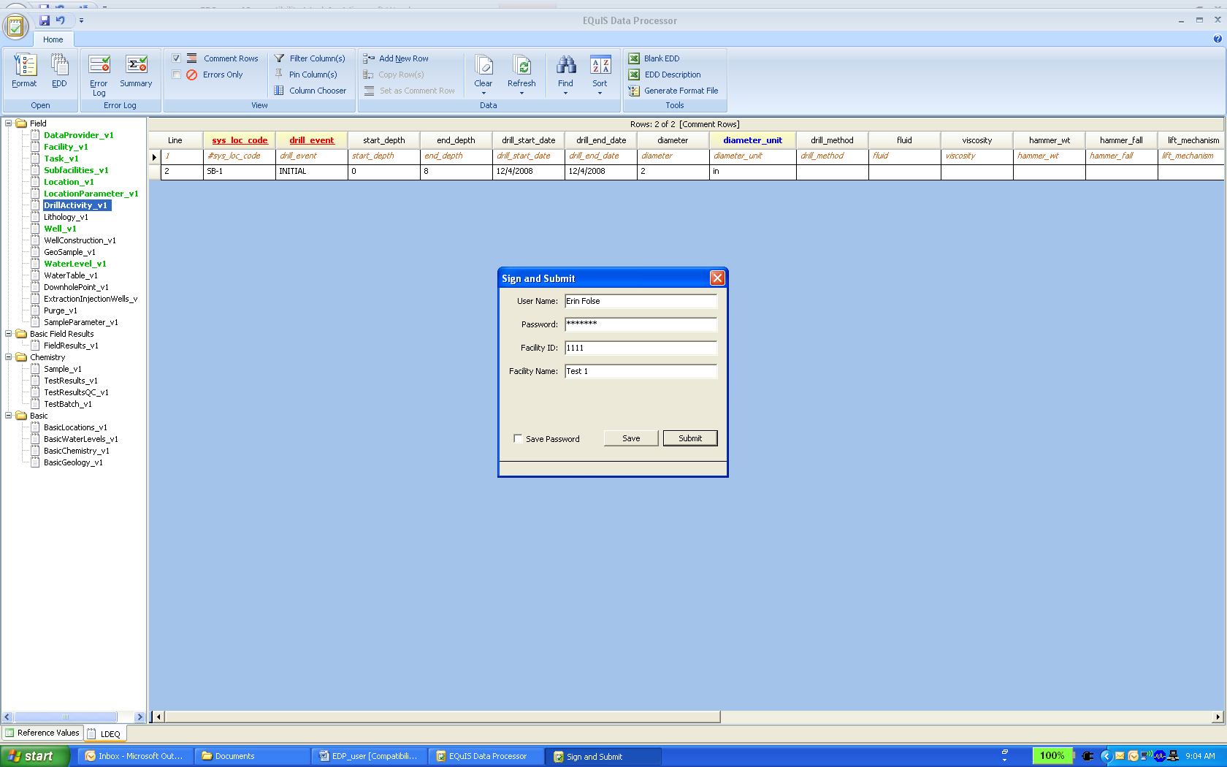

Select Save then choose the directory to save your data package In the file name the program will default the file name as <data and time>.<AI number>.LDEQ.zip The default name resulting in the following example.

20081209_0906.1111.LDEQ.zip

Once you have named your file, click “Save” and you will get the following window. The file will be saved in the directory you selected. It will be a zip file with each EDD file and your user certificated packaged in a zip file.

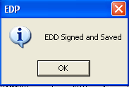

Sign and Submit a Data Package

NOTE: Laboratories do not directly submitted to LEADMS. They will forward the EDD package contractor they do the analysis for or to deqlabinfo@la.gov if contracted out by LDEQ.

Once all data has been corrected you are ready to prepare the data package for submittal. To do this, with the data loaded in the EDP application, click on icon in the upper right hand corner and select Sign and Submit.

Enter your user name, password and the AI number of the facility you are submitting data to in the Facility ID field and the facility name. Then click on Submit. Your data package will be submitted to the database, checked, and imported as long as no errors are found. If errors were found, the data submitter will receive an email with an error log of errors that need to be corrected. If the EDDs was error free you will receive a confirmation email that your EDDs were accepted with no errors.

Updating the Reference Value file

Periodically, LDEQ will post an updated reference value file on the LDEQ LEADMS website at: http://deq.louisiana.gov/page/leadms-resource-page . Data providers can update the reference values in their EDP application by following the steps below:
- Go to above Web Page and click on Current Reference Value File for EDP link.
- Click Open, then click Extract in top menu bar.
- Extract to select C:\Program Files\EarthSoft\EDP\Formats\LDEQ then click extract.
- You will get a window asking if you would like to replace existing file. Select Yes.
- The next time the format file loads in the EDP, the new reference values will be loaded.
NOTE: If there is a reference value you require and it is not currently available, email DEQ-LEADMSQuestions@la.gov requesting it to be added.

Updating the Format File

When LDEQ makes changes to the format file, the data provider will need to update their EDP application with the new format. Data providers can update the format file by downloading format file from: http://www.earthsoft.com/wordpress/products/edp/edp-format-for-ladeq/
NOTE: The data provider is responsible for checking LDEQ’s website for recent updates.

References

  - EarthSoft Website
  - LDEQ LEADMS web page
  - LDEQ’s Electronic Data Deliverables (EDD) Data Submittal Requirements Manual
  - Appendix A – Examples of EDD errors identified by the EDP

Appendix A
Examples of EDD errors identified by the EDP

EDP has the ability to check for errors within an individual EDD and also relationships between EDDs. With LDEQ’s business rules it checks for the following issues:
- Field Lengths
- Valid Values
- Required Fields
- Data Types
- Valid Dates
- Duplicate Records
- Parent-child relationships.

Valid Value Not found (green)

The value in the field does not match the values listed in the valid value appendix of the LDEQ EDD Data Submittal Requirements Manual. If value does not exist in the appendix and you feel it should be a valid value contact Erin.Folse@la.gov or DEQ-LEADMSQuestions@la.gov to request a new valid value be added to the reference value list.
- Value exceeds field length (yellow)
The number of characters in the value exceeds the maximum allowed number of characters in that field. See LDEQ EDD Data Submittal Requirements Manual for maximum field lengths.
- Missing a Required Field (red)
A required field was left null. All required field must have a value.
A common problem arises with the CAS RN field during the conversion of file type. Sometimes in Excel a CAS RN appears as a date because of dashes and Excel tries to convert to a date. An example is the CAS RN for Potassium is 7440-09-07 will be converted to 9/7/7440
- Invalid Data Type (purple)
The value entered is not the appropriate data type. Each field expects specific data type such as text, date/time or numeric. Example time format should be entered as HH:MM:SS if it is entered as H:MM invalid data type error will appear.
Another common problem arises with Date/Time fields. The Date/Time fields may be converted to a Julian date. Check your date fields if this problem arises.
- Duplicate Row (orange, yellow strip)
Two or more records have the same value in the primary key field. The primary key field must be unique for each record.
- Orphan Row (blue, yellow strip)
The record is missing a parent record. Some records depend on information in another record and the parent record must exist. Example when the Sample_v1 and TestResults_v1 are populated with data the sys_sample_code in TestResults_v1 must match the sys_sample_code in Sample_v1 table.
- Detect flag is N the reporting detection limit value cannot be null (yellow)
If the result was not detected, then the detect flag field would be populated with N and then the reporting detection limit field requires a value. If the result is detected, then detect field would be populated with Y because a result value is reported.
- Parent sample code required when sample type equals BD, FD, FR, FS, SD (purple)
All duplicate samples require the parent sample code.
- Dates not in Sequence
Errors are identified if certain dates precede other dates. Example: an analysis date can not precede the sample date.
- Sys loc code required when sample type code is N (hot pink)
The location must be provided for every normal (N) sample collected

