
Louisiana Department of Environmental Quality
Source Water Assessment Program

Potential Susceptibility Assessment of a

Ground Water Source of Public Drinking Water

Basis for Assessment

The following sections contain information necessary to understand how and why this assessment was conducted. It is important to review this information to understand what the ranking of this source means. A map showing the delineated source water protection area and the inventory of significant potential sources of contamination identified within that area are attached. The list of significant potential sources and their rankings used to develop the assessment is also attached. If you have any questions regarding this assessment, please contact DEQ, Water Quality Management Division at 225-765-0578, or call 1-800-263-4012.

A. Background

Under the Safe Drinking Water Act Amendments of 1996, all states are required by the U.S. Environmental Protection Agency (EPA) to asses every source of public drinking water for its relative susceptibility to contaminants regulated by the Act. This assessment is based on a land use inventory of the delineated protection area and sensitivity factors associated with the well and aquifer characteristics.

B. Level of Accuracy and Purpose of the Assessment

Since there are over 2000 public water supply systems in Louisiana, there is limited time and resources to accomplish these assessments. All assessments must be completed by May 6, 2003. An in-depth, site-specific investigation of each significant potential source of contamination was not possible. Therefore, this assessment should be used as a planning tool, taken into account with local knowledge and concerns, to develop and implement appropriate protection measures for this source. The results should not be used as an absolute measure of risk and they should not be used to undermine public confidence in their water system.

Methodology

A. Identification of Significant Potential Sources of Contamination

A significant potential source of contamination (SPSOC) is defined as any facility or activity that stores, uses, or produces, as a product or by-product, the contaminants regulated under the Safe Drinking Water Act and has a sufficient likelihood of releasing such contaminants at levels that could pose a concern relative to drinking water sources. The SPSOC locations were obtained by field surveys conducted by DEQ and from available databases.

B. Potential for Contamination by Significant Potential Sources of Contamination Identified on the Map

Potential contamination sources are facilities that use, produce, or store contaminants of concern (those regulated under the Safe Drinking Water Act) which, if improperly managed, could find their way into a source of public drinking water. It is important to understand that a release may never occur from a SPSOC provided they are using best management practices. Many SPSOC are regulated at the federal level, state level, or both to reduce the risk of a release. There are a number of methods that water systems can use to work cooperatively with SPSOC. These often involve educational visits and inspections of stored materials. Many owners of such facilities may not even be aware that they are located near a public water supply well.

C. Ranking of Significant Potential Sources of Contamination

Significant potential sources of contamination were ranked as high, medium, or low risk according to the following considerations: 1) Sources of ground water contamination in the past, 2) Sources of ground water contamination in the past which have caused contamination of public water supply wells, 3) Review of ranking schemes in the literature from other states and the U.S. EPA, and 4) Experience of DEQ staff. An important consideration is the proximity of significant potential sources to the well. Potential contamination sources located in closest proximity to the wells will pose the greatest threat. The greater the distance the less chance of contamination, because dilution, sorption, and degradation increase with distance. Most public water supply contamination incidents in the State of Louisiana have resulted from either leaking underground storage tanks or surface spills of gasoline in the vicinity of the wells. These plumes usually do not move beyond 1000 feet as natural bacteria in the soil usually break down the gasoline through natural degradation processes. The further away a significant potential source of contamination is located from the well the lower the risk to the well, even if the SPSOC is considered to be a high-risk activity or facility.

D. Determination of water well sensitivity

The overall sensitivity ranking of for water wells was derived considering the following factors:

- Depth of well - the shallower the well, the higher the sensitivity. Deeper wells are afforded natural protection due to the presence of clay or “confining” layers present in the subsurface. These layers substantially restrict or impede the flow of water (and possible contaminants) from the surface and shallow subsurface to deeper aquifers tapped by deep wells. Historically, contamination of public water supply wells in Louisiana has occurred in wells screened at relatively shallow depths, or less than 350 feet below land surface.

- Age of the well - the older the well, the more sensitive. As wells age, the grouting and casing can deteriorate. If a well was drilled prior to construction standards of November 1985, it is also considered more sensitive since it may not be properly constructed. Deteriorated or improperly constructed wells can provide conduits for contaminants to enter the aquifer from the surface or shallow subsurface.
- Aquifer - the higher the average ground water flow velocity, the higher the sensitivity. The faster the ground water flows, the faster it will carry contaminants to the well. This was based on the average ground water velocity of the aquifer in which the well is completed.

- Soil Recharge Potential - the sandier the soils the higher the sensitivity. Sandy soils allow more water to infiltrate from the surface to the subsurface than do silt or clay soils. This was based on the State of Louisiana Aquifer Recharge Potential Map developed for DEQ by the Louisiana Geological Survey in 1989.

Prioritization for Protection Activities

This susceptibility assessment should be used as a basis for determining appropriate new protection measures or reevaluating current protection efforts. No matter what the susceptibility ranking a source receives, protection is always important. Whether the source is currently located in a “pristine” area or an area with numerous industrial landuses that require education and surveillance, the way to ensure good water quality in the future is to act now to protect valuable water supply resources.

An effective source water protection program is tailored to the particular local source water protection area. It is the intent of DEQ to begin protection activities when the Source Water Assessment Program is completed. A comparative potential susceptibility analyses will be conducted upon completion of all assessments to determine a relative risk ranking among all public water supply systems. The results of this analysis will be used to develop a prioritization scheme for implementing protection activities. The comparison is based on the well sensitivity analysis and the density of potential sources of contamination for each well.

Source Water Assessment Results

Water System Name: Anytown, LA

PWS ID Number: 10339999

Protection Area Radius: 1 Mile

Date of Assessment: July 16, 1999

A. Sensitivity Analysis – based on the depth and age of the well, the average ground water velocity in the aquifer, and the soil recharge potential.

Well | Ranking | Comments
10339999 - 1 | Medium | 550’ deep in Southern Hills aquifer, drilled 1986, low recharge potential

B. Vulnerability Analysis – based on the types and numbers of significant potential sources of contamination (SPSOC) and their distances from the well

Well | # High Risk SPSOC  W/in 1000’ | # Medium Risk SPSOC  W/in 1000’ | # Low Risk SPSOC  W/in 1000’ | # High Risk SPSOC  >1000’ | # Medium Risk SPSOC  >1000’ | # Low Risk SPSOC  >1000’
10339999-1 | 1 | 1 | 0 | 4 | 1 | 2

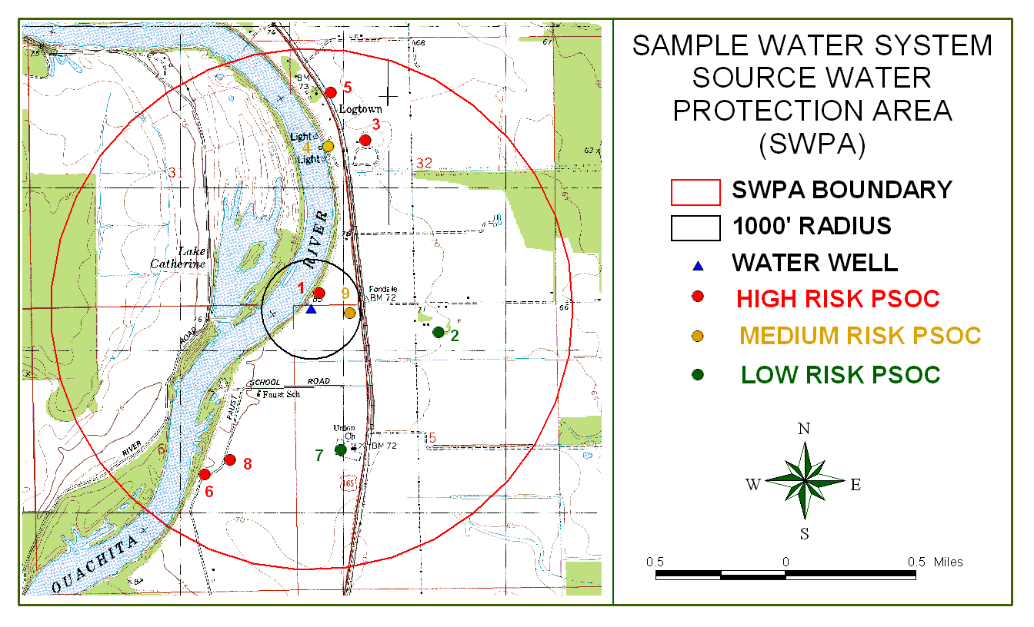

Source Water Protection Area Inventory
Anytown, LA

MAPNO 1

DESCRIPT Mike's Gas for Less - USTs

ADDRESS 123 Main St., Anytown, LA 70000

PHONE (225) 765-0585

OWNNAME Mike Brown

OWNADDRESS 2323 Birch St., Anytown, LA 70000

OWNPHONE (225) 765-0602

STATUS Active

RISK RANK High

MAPNO 2

DESCRIPT Self Serve Car Wash

ADDRESS Railroad Ave.

PHONE N/A

OWNNAME Coin Car Washes, Inc.

OWNADDRESS 345 Main St., Anytown, LA 70000

OWNPHONE (225) 765-0578

STATUS Active

RISK RANK Low

MAPNO 3

DESCRIPT Town Maintenance Barn - Above Ground Storage Tank
(diesel fuel)

ADDRESS 567 E. Circle Dr., Anytown, LA 70000

PHONE (225) 765-0621

OWNNAME Town of Anytown

OWNADDRESS 900 Main St., Anytown, LA 70000

OWNPHONE (225) 765-0056

STATUS Active

RISK RANK High

MAPNO 4

DESCRIPT Gravel Pit

ADDRESS end of Long St. at the river

PHONE N/A

OWNNAME Gravel and Fill,Inc.

OWNADDRESS P.O. Box 5000, Baton Rouge,LA 70809

OWNPHONE (225) 765-5000

STATUS Active

RISK RANK Medium

MAPNO 5

DESCRIPT Harry's Hardware - Above Ground Storage Tank (diesel)

ADDRESS 6879 Hwy. 165, Anytown, LA 70000

PHONE (225) 765-0625

OWNNAME Harry Smith

OWNADDRESS 765 Elm St., Anytown, LA 70000

OWNPHONE (225) 765-0577

STATUS Active

RISK RANK High

MAPNO 6

DESCRIPT Jay's Golden Cleaners - Dry Cleaner

ADDRESS 211 Faust Rd., Anytown, LA 70000

PHONE (225) 765-0586

OWNNAME Jay Connor

OWNADDRESS 956 Cypress Ave., Anytown, LA 70000

OWNPHONE (225) 765-0584

STATUS Active

RISK RANK High

MAPNO 7

DESCRIPT Union Church Cemetery - located behind church

ADDRESS 6088 Hwy. 165, Anytown, LA 70000

PHONE N/A

OWNNAME Union Baptist Church

OWNADDRESS 6088 Hwy.165, Anytown, LA 70000

OWNPHONE (225) 765-0065

STATUS N/A

RISK RANK Low

MAPNO 8

DESCRIPT Circle K - USTs

ADDRESS 300 Faust Rd., Anytown, LA 70000

PHONE N/A - closed

OWNNAME Circle K Stores,Inc.

OWNADDRESS P.O. Box 56740, Houston, TX 57869

OWNPHONE 1-800-877-9977

STATUS Abandoned

RISK RANK High

MAPNO 9

DESCRIPT Ace Furniture Finishers

ADDRESS 345 Main St., Anytown, LA 70000

PHONE (225) 765-7060

OWNNAME Joe Campbell

OWNADDRESS 840 Fig St., Anytown, LA 70000

OWNPHONE (225) 765-6373

STATUS Active

RISK RANK Medium

POTENTIAL CONTAMINATION SOURCE CONTROL CONTACTS

Source | Contact
Active And Inactive Hazardous Waste Sites-Operating Facility | Department of Environmental Quality  Remediation Services Division  Post Office Box 82178  Baton Rouge, LA 70884-2178  (225) 765-0355  Keith Casanova or Roger Gingles
Waste Impoundments of Oil & Gas Industry | Department of Natural Resources  Oilfield Waste & Underground Injection Wells & Mining Division  Post Office Box 94275  Baton Rouge, LA 70804-9275  (225) 342-5524  Brent Campbell
Pipelines for Natural Gas, Crude Oil, & other Fluids | Department of Natural Resources  Pipelines Division  Post Office Box 94275  Baton Rouge, LA 70804-9275  (225) 342-5505  Joel Kohler or James Mergist  or call collect the company listed on pipeline marker
Inactive & Abandoned Sites | Department of Environmental Quality  Remediation Services Division  Post Office Box 82178  Baton Rouge, LA 70884-2178  (225) 765-0355  John Halk  Program Manager

Underground Storage Tanks | Department of Environmental Quality  Remediation Services Division  Post Office Box 82178  Baton Rouge, LA 70884-2178  (225) 765-0355  Raul Busquet  Program Manager
Underground Injection | Department of Natural Resources  Oilfield Waste and Underground  Injection Wells & Mining Division  Post Office Box 94275  Baton Rouge, LA 70804-9275  (225) 342-5515  Carroll Wascom or Doyle Johnson
Abandoned Wells other than Water Wells | Department of Natural Resources  Post Office Box 94275  Baton Rouge, LA 70804-9275  (225) 342-5540  Gary Ross
Abandoned Water Wells | Department of Transportation and Development  Water Resources Section  Post Office Box 94245  Baton Rouge, LA 70804-9245  (225) 379-1434  Z. "Bo" Bolourchi, Chief
Agriculture | Department of Agriculture and Forestry  Post Office Box 3596  Baton Rouge, LA 70821-3596  (225) 925-3768  Larry LeJeune, Director of the Pesticides and Environmental Programs
Drinking Water | Department of Health and Hospitals  R. Douglas Vincent,  Chief Engineer  6867 Bluebonnet Blvd.  Baton Rouge, LA 70810  (225) 765-5038
Solid Waste | Department of Environmental Quality  Remediation Services Division  Post Office Box 82178  Baton Rouge, LA 70884-2178  (225) 765-0355  Monroe Penrod  Program Manager

Surface Discharge | Department of Environmental Quality  Office of Environmental Compliance  Surveillance Division  Post Office Box 82215  (225) 765-0634  Baton Rouge, La 70884-2215  Chris Piehler  Program Manager
Citizen 24-hour Hotline  (Complaints) (Spills) | Department of Environmental Quality  (225) 342-1234
Customer Information Number | (888) 763-5424
Source Water Assessment | Department of Environmental Quality  Environmental Evaluation Division  Post Office Box 82178  Baton Rouge, LA 70884-2178  (225) 765-0578  Howard Fielding  Mary Gentry

Sole Source Aquifer Information

There are two aquifers in Louisiana designated as Sole Source Aquifers by the U.S. EPA: the Chicot Aquifer and the Southern Hills Regional Aquifer System. If a public water supply system is drawing form either the Chicot Aquifer or one of the aquifer units in the Southern Hills Regional Aquifer System, information on the Sole Source Aquifer Program will be reported to that system in its completed assessment. EPA Region 6 has agreed to provide us with brochures for this purpose.

