
Louisiana Department of Environmental Quality
Source Water Assessment Program

Potential Susceptibility Assessment of a

Surface Water Source of Public Drinking Water

Basis for Assessment

The following sections contain information necessary to understand how and why this assessment was conducted. It is important to review this information to understand what the ranking of this source means. A map showing the delineated source water protection area and the inventory of significant potential sources of contamination identified within that area are attached. The list of significant potential sources and their rankings used to develop the assessment is also attached. If you have any questions regarding this assessment, please contact DEQ, Environmental Evaluation Division at 225-765-0578 or call 1-800-263-4012.

A. Background

Under the Safe Drinking Water Act Amendments of 1996, all states are required by the U.S. Environmental Protection Agency (EPA) to assess every source of public drinking water for its relative susceptibility to contaminants regulated by the Act. This Phase I assessment is based on a land use inventory of the delineated protection area. A Phase II assessment will also include sensitivity factors associated with the intake and source water. The Phase II assessment will be conducted upon completion of all source water assessments for systems using surface as a drinking water source.

B. Level of Accuracy and Purpose of the Assessment

Since there are over 2000 public water supply systems in Louisiana, there is limited time and resources to accomplish these assessments. All assessments must be completed by May 6, 2003. An in-depth, site-specific investigation of each significant potential source of contamination was not possible. Therefore, this assessment should be used as a planning tool, taken into account with local knowledge and concerns, to develop and implement appropriate protection measures for this source. The results should not be used as an absolute measure of risk and they should not be used to undermine public confidence in their water system.

Methodology

A. Identification of Significant Potential Sources of Contamination

A significant potential source of contamination (SPSOC) is defined as any facility or activity that stores, uses, or produces, as a product or by-product, the contaminants regulated under the Safe Drinking Water Act and has a sufficient likelihood of releasing such contaminants at levels that could pose a concern relative to drinking water sources. The SPSOC locations were obtained by field surveys conducted by DEQ and from available databases.

B. Potential for Contamination by Significant Potential Sources of Contamination Identified on the Map

Potential contamination sources are facilities that use, produce, or store contaminants of concern (those regulated under the Safe Drinking Water Act) which, if improperly managed, could find their way into a source of public drinking water. It is important to understand that a release may never occur from a SPSOC provided they are using best management practices. Many SPSOC are regulated at the federal level, state level, or both to reduce the risk of a release. There are a number of methods that water systems can use to work cooperatively with SPSOC. These often involve educational visits and inspections of stored materials. Many owners of such facilities may not even be aware that they are located near a public water supply intake.

C. Ranking of Significant Potential Sources of Contamination

Significant potential sources of contamination were ranked as high, medium, or low risk according to the following considerations: 1) Sources of surface water contamination in the past, 2) Sources of surface water contamination in the past which have caused contamination of public water supply intakes, 3) Review of ranking schemes in the literature from other states and the U.S. EPA, and 4) Experience of DEQ staff. An important consideration is the proximity of significant potential sources to the water body. Potential contamination sources located in closest proximity to the water body will pose the greatest threat. The greater the distance the less chance of contamination, because dilution and degradation increase with distance. Most public surface water supply contamination incidents in the State of Louisiana have resulted from spills, accidents, or pesticide application. The further away a significant potential source of contamination is located from the water body the lower the risk to the intake, even if the SPSOC is considered to be a high-risk activity or facility.

D. Determination of Intake and Source Sensitivity

Since surface water sources are open to the atmosphere, they are considered inherently sensitive. However, data collected from each system during the source water assessments will be used to develop a comparative sensitivity ranking among surface water systems. The overall sensitivity ranking will be derived considering the following factors:

- Structural integrity of the intake – inferred from the age of the intake. The older the intake, the higher the sensitivity.

- Length of streams in the source water protection area - the assumption is that there is a greater potential for negative impact on surface water when the length of rivers and streams in the area is high. The stream data will be obtained from the U.S. Geological Survey.

- Runoff – there is greater potential for negative impact on the surface water when the runoff is high. Factors that influence runoff are precipitation, slope, vegetative cover, and soil permeability. High precipitation, steep slope, low vegetative cover, and low soil permeability contribute to high runoff. The precipitation data will be obtained from the Louisiana Office of State Climatology, Southern Region Climate Center at Louisiana State University. The slope data will be obtained from the U.S. Department of Agriculture Soil Conservation Service soils geographic database (STATSGO). The vegetative cover data will be obtained from the U.S. Geological Survey. Soil permeability data will be obtained from the State of Louisiana Aquifer Recharge Potential Map prepared for DEQ by the Louisiana Geological Survey, and from the U.S. Department of Agriculture Soil Conservation Service soil surveys.

Prioritization for Protection Activities

This susceptibility assessment should be used as a basis for determining appropriate new protection measures or reevaluating current protection efforts. No matter what the susceptibility ranking a source receives, protection is always important. Whether the source is currently located in a “pristine” area or an area with numerous industrial landuses that require education and surveillance, the way to ensure good water quality in the future is to act now to protect valuable water supply resources.

An effective source water protection program is tailored to the particular local source water protection area. It is the intent of DEQ to begin protection activities when the Source Water Assessment Program is completed. However, local water supplies or communities may take steps to address SPSOCs of particular concern by contacting the appropriate state regulatory agency shown in the attached List of Regulatory Contacts. A comparative potential susceptibility analyses will be conducted upon completion of all assessments to determine a relative risk ranking among all public water supply systems. The results of this analysis will be used to develop a prioritization scheme for implementing protection activities. The comparison is based on the intake and source sensitivity analysis and the density of potential sources of contamination for each intake.

Source Water Assessment Results

Water System Name: Anytown, LA

PWS ID Number: 1036777

Water Source: Georgetown Reservior

Date of Assessment: August 31, 1999

Vulnerability Analysis – based on the types and numbers of significant potential sources of contamination (SPSOC) and their distances from the surface water source.

Intake | # High Risk SPSOC  W/in Critical Area* | # Medium Risk SPSOC  W/in Critical Area* | # Low Risk SPSOC  W/in Critical Area* | # High Risk SPSOC  Outside Critical Area* | # Medium Risk SPSOC  Outside Critical Area* | # Low Risk SPSOC  Outside Critical Area*
1 | 2 | 2 | 2 | 0 | 0 | 1

* Critical Area is defined as a 1000 foot perimeter around lakes and reservoirs and 1000’ from the banks on either side of rivers and streams for a distance of 5 linear miles upstream of the intake. SPSOCs located within the critical area were identified by a field survey. SPSOCs located outside of the critical area were identified by a database search.

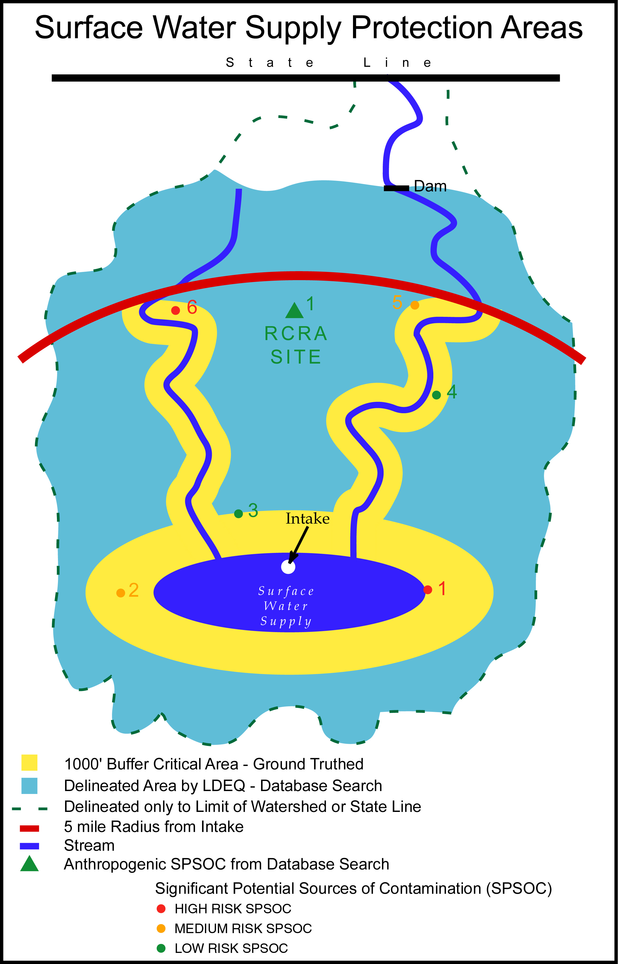

Source Water Protection Area Field Inventory
Anytown, LA

MAPNO 1

DESCRIPT Mike's Gas for Less - USTs

ADDRESS 123 Main St., Anytown, LA 70000

PHONE (225) 765-0585

OWNNAME Mike Brown

OWNADDRESS 2323 Birch St., Anytown, LA 70000

OWNPHONE (225) 765-0602

STATUS Active

RISK RANK High

MAPNO 2

DESCRIPT Harry's Plant Nursery

ADDRESS 343 Main St, Anytown, LA 70000

PHONE (225) 765-0625

OWNNAME Harry Smith

OWNADDRESS 765 Elm St., Anytown, LA 70000

OWNPHONE (225) 765-0577

STATUS Active

RISK RANK Medium

MAPNO 3

DESCRIPT Self Serve Car Wash

ADDRESS Railroad Ave.

PHONE N/A

OWNNAME Coin Car Washes, Inc.

OWNADDRESS 345 Main St., Anytown, LA 70000

OWNPHONE (225) 765-0578

STATUS Active

RISK RANK Low

MAPNO 4

DESCRIPT Union Church Cemetery - located behind church

ADDRESS 6088 Hwy. 165, Anytown, LA 70000

PHONE N/A

OWNNAME Union Baptist Church

OWNADDRESS 6088 Hwy.165, Anytown, LA 70000

OWNPHONE (225) 765-0065

STATUS N/A

RISK RANK Low

MAPNO 5

DESCRIPT Ace Furniture Finishers

ADDRESS 9334 Hwy. 165, Anytown, LA 70000

PHONE (225) 765-7060

OWNNAME Joe Campbell

OWNADDRESS 840 Fig St., Anytown, LA 70000

OWNPHONE (225) 765-6373

STATUS Active

RISK RANK Medium

MAPNO 6

DESCRIPT Town Maintenance Barn - Above Ground Storage Tank
(diesel fuel)

ADDRESS 9272 Hwy 3002, Anytown, LA 70000

PHONE (225) 765-0621

OWNNAME Town of Anytown

OWNADDRESS 900 Main St., Anytown, LA 70000

OWNPHONE (225) 765-0056

STATUS Active

RISK RANK High

Source Water Protection Database Inventory
Anytown, LA

MAPNO 1

DESCRIPT ABC Chemical Distributors (RCRA facility)

ADDRESS 32433 Industrial Row, Anytown, LA 70000

PHONE (225) 765-0585

OWNNAME ABC, Inc.

OWNADDRESS P.O. Box 45, Baton Rouge, LA 70809

OWNPHONE (225) 765-0602

STATUS Active

RISK RANK Low

POTENTIAL CONTAMINATION SOURCE CONTROL CONTACTS

Source | Contact
Active And Inactive Hazardous Waste Sites-Operating Facility | Department of Environmental Quality  Remediation Services Division  Post Office Box 82178  Baton Rouge, LA 70884-2178  (225) 765-0355  Keith Casanova or Roger Gingles
Waste Impoundments of Oil & Gas Industry | Department of Natural Resources  Oilfield Waste & Underground Injection Wells & Mining Division  Post Office Box 94275  Baton Rouge, LA 70804-9275  (225) 342-5524  Brent Campbell
Pipelines for Natural Gas, Crude Oil, & other Fluids | Department of Natural Resources  Pipelines Division  Post Office Box 94275  Baton Rouge, LA 70804-9275  (225) 342-5505  Joel Kohler or James Mergist  or call collect the company listed on pipeline marker
Inactive & Abandoned Sites | Department of Environmental Quality  Remediation Services Division  Post Office Box 82178  Baton Rouge, LA 70884-2178  (225) 765-0355  John Halk  Program Manager

Underground Storage Tanks | Department of Environmental Quality  Remediation Services Division  Post Office Box 82178  Baton Rouge, LA 70884-2178  (225) 765-0355  Raul Busquet  Program Manager
Underground Injection | Department of Natural Resources  Oilfield Waste and Underground  Injection Wells & Mining Division  Post Office Box 94275  Baton Rouge, LA 70804-9275  (225) 342-5515  Carroll Wascom or Doyle Johnson
Abandoned Wells other than Water Wells | Department of Natural Resources  Post Office Box 94275  Baton Rouge, LA 70804-9275  (225) 342-5540  Gary Ross
Abandoned Water Wells | Department of Transportation and Development  Water Resources Section  Post Office Box 94245  Baton Rouge, LA 70804-9245  (225) 379-1434  Z. "Bo" Bolourchi, Chief
Agriculture | Department of Agriculture and Forestry  Post Office Box 3596  Baton Rouge, LA 70821-3596  (225) 925-3768  Larry LeJeune, Director of the Pesticides and Environmental Programs
Drinking Water | Department of Health and Hospitals  R. Douglas Vincent,  Chief Engineer  6867 Bluebonnet Blvd.  Baton Rouge, LA 70810  (225) 765-5038
Solid Waste | Department of Environmental Quality  Remediation Services Division  Post Office Box 82178  Baton Rouge, LA 70884-2178  (225) 765-0355  Monroe Penrod  Program Manager

Surface Discharge | Department of Environmental Quality  Office of Environmental Compliance  Surveillance Division  Post Office Box 82215  (225) 765-0634  Baton Rouge, La 70884-2215  Chris Piehler  Program Manager
Citizen 24-hour Hotline  (Complaints) (Spills) | Department of Environmental Quality  (225) 342-1234
Customer Information Number | (888) 763-5424
Source Water Assessment | Department of Environmental Quality  Environmental Evaluation Division  Post Office Box 82178  Baton Rouge, LA 70884-2178  (225) 765-0578  Howard Fielding  Mary Gentry

